Screen Design Document
Screens, layouts, controls, navigation and visual style
Product | Falcon OCR 1.0
Document ID | FOCR-SCR-001
Version | 1.0
Date | 2026-09-24
Status | Released for review
Prepared by | Falcon OCR Development Team
This document defines every screen and dialog of Falcon OCR 1.0: purpose, layout, controls and their behavior, navigation, messages and the visual style guide. It is the reference for UI implementation and UI testing.
Document control
Version | Date | Author | Changes
0.9 | 2026-09-20 | Falcon OCR Development Team | Draft for internal review.
1.0 | 2026-09-24 | Falcon OCR Development Team | Released with Falcon OCR 1.0: OCR engine, layout reconstruction, exports, trial and licensing.
Contents
1. Introduction 3
2. Visual style guide 4
2.1 Colors 4
2.2 Typography and icons 4
2.3 Interaction conventions 4
3. SCR-01 Main window shell 6
4. SCR-02 Home — workspace 7
4.1 Layout 7
4.2 Toolbar 7
4.3 Files panel 8
4.4 Source Page viewer 8
4.5 Results panel 9
4.6 Settings column 9
5. SCR-03 Original Image (analysis overlay) 11
6. SCR-04 Quick OCR 12
7. SCR-05 Batch Process 13
8. SCR-06 History 14
9. SCR-07 Settings 15
10. SCR-08 Activation window 16
11. SCR-09 Advanced OCR Settings 18
12. SCR-10 Other dialogs and messages 19
13. SCR-11 License Key Generator (vendor) 20
14. Navigation map 21

1. Introduction
The user interface follows the ABBYY FineReader-style reference supplied by the product owner: a green title bar, a dark-green navigation bar on the left, a ribbon toolbar, the document list, the source page and the recognition result side by side, and a settings column with a prominent Export button. Screen identifiers (SCR-nn) are referenced by the Test Case Specification.
Table 1 – Screen inventory
ID | Screen / dialog | Opened from
SCR-01 | Main window shell (title bar, navigation, status bar) | Application start
SCR-02 | Home — workspace | Navigation 'Home' (start screen)
SCR-03 | Home — Original Image (analysis overlay) | Results tab 'Original Image'
SCR-04 | OCR — Quick OCR | Navigation 'OCR'
SCR-05 | Batch Process | Navigation 'Batch Process'
SCR-06 | History | Navigation 'History'
SCR-07 | Settings | Navigation 'Settings', toolbar link 'Settings'
SCR-08 | Activation window (trial running / trial ended) | Start-up without license, trial badge, Settings → License
SCR-09 | Advanced OCR Settings dialog | OCR Settings → Advanced Settings…
SCR-10 | Rename / message dialogs, context menus | File list context menu, Help
SCR-11 | License Key Generator (vendor tool) | FalconOcrKeyGen.exe

2. Visual style guide

2.1 Colors
Table 2 – Color palette
Token | RGB | Use
Header | #0E6E4C | Title bar, dialog headers
Sidebar | #10704E → #0A583E (gradient) | Navigation bar
Sidebar selected / hover | #3A9670 / #22825E | Current page / hover in navigation
Accent | #13865C | Primary buttons, selected tab underline, icons, links
Accent light / hover | #E1F3EB / #EEF8F3 | Selected list item, button hover
Window / Panel | #F4F6F8 / #FFFFFF | Background / cards
Border | #DEE3E8 | Card and panel borders
Text / Sub-text | #1F2937 / #64707E | Body text / secondary text
Canvas | #E2E6EA | Viewer background around the page
Low confidence | #FFD600 (35 % alpha) | Uncertain characters in the results
Trial badge | #FFC107 | Title bar trial badge
Danger | #C82828 | Errors, Stop button

2.2 Typography and icons
- Segoe UI 9.75 pt for controls; Segoe UI Semibold 10 pt (bold), 12 pt (card titles), 15 pt (page titles), 17 pt (product name); navigation 11 pt.
- Icons are vector glyphs drawn with GDI+ on a 24 × 24 grid (no bitmaps), so they are sharp at every DPI: Home, OCR, Batch, History, Settings, Help, Add, Scanner, Clipboard, Rotate, Crop, Trash, Play/Stop, Export, zoom, fit, hand, chevrons, file types (PDF, image, images, Word, Excel, HTML).
- All sizes are scaled with the monitor DPI (system DPI aware).

2.3 Interaction conventions
- Primary action per screen in a filled green button (Export, Start, Save, Activate, Generate License Key).
- Hover highlight on all clickable owner-drawn controls; disabled controls are grey.
- Long operations show progress in the status bar and can be stopped (Recognize → Stop, Batch Start → Stop).
- Confirmation before destructive actions (remove recognized documents, clear history, new signing key).

3. SCR-01 Main window shell
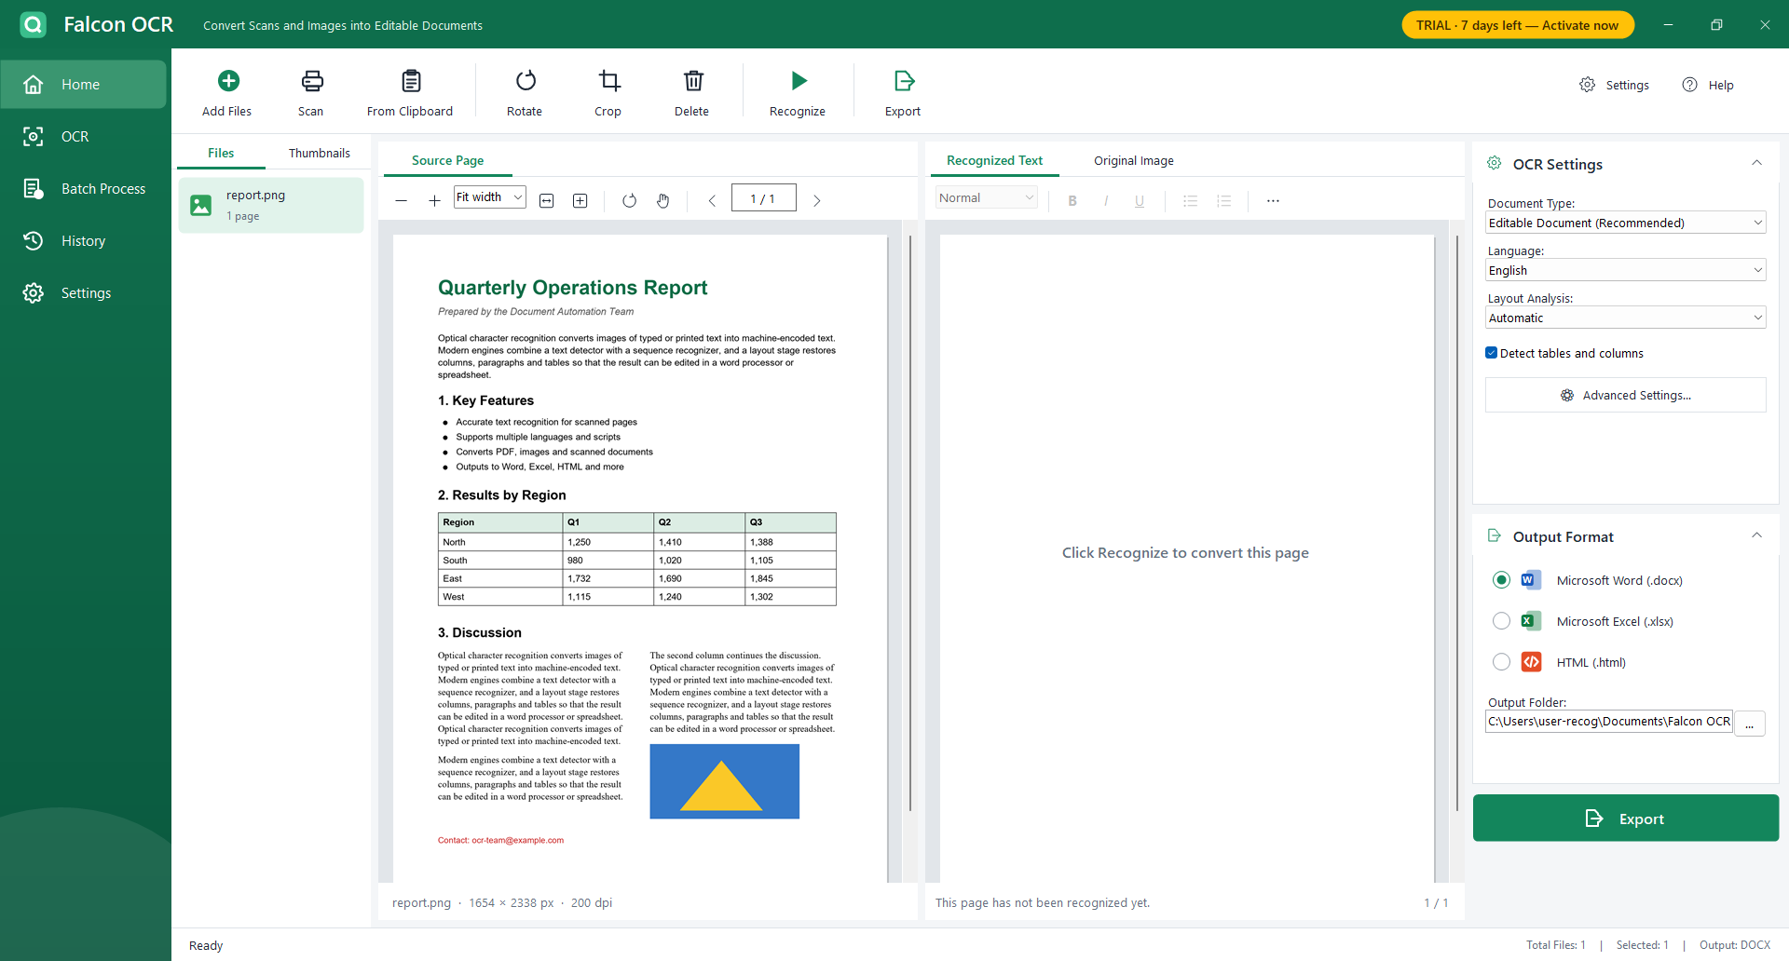
Figure 1 – Main window with a document loaded (trial mode)
Table 3 – SCR-01 regions
Region | Content and behavior
Title bar (52 px, green) | Logo, 'Falcon OCR', tagline 'Convert Scans and Images into Editable Documents'. Drag to move, double-click to maximise/restore. Trial badge 'TRIAL · n days left — Activate now' (only while unlicensed; click opens SCR-08). Minimise, maximise/restore, close (red hover).
Navigation bar (184 px) | Home, OCR, Batch Process, History, Settings. The current page is highlighted with a rounded light-green background.
Content | The selected page (SCR-02 … SCR-07).
Status bar (36 px) | Left: status message ('Ready', progress text) and progress bar during recognition/batch. Right: 'Total Files: n | Selected: n | Output: DOCX'.
Window | Borderless, resizable at the 6 px edge, maximises to the monitor work area (taskbar stays visible), remembers size/position and maximised state.

4. SCR-02 Home — workspace
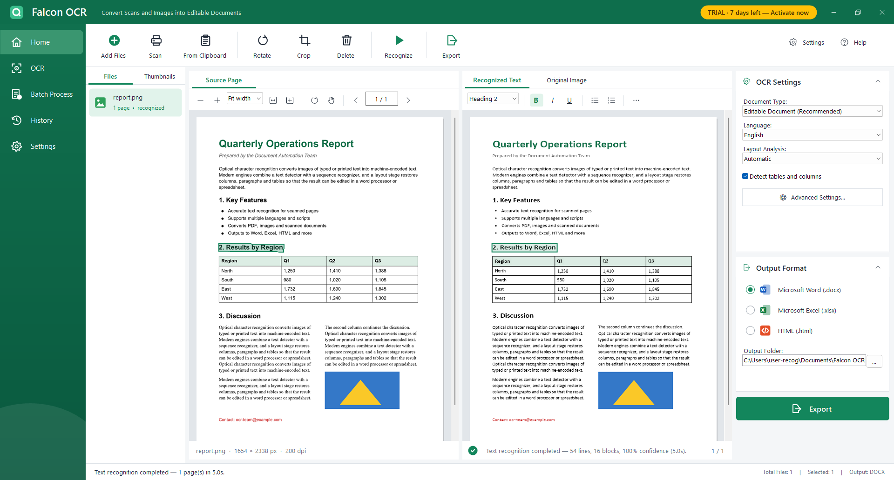
Figure 2 – Workspace after recognition; the selected line is highlighted on both sides

4.1 Layout
Table 4 – SCR-02 regions
Region | Width | Content
Toolbar | full, 92 px | Add Files, Scan, From Clipboard | Rotate, Crop, Delete | Recognize | Export; right: Settings, Help.
Files panel | 214 px | Tabs Files / Thumbnails; document list (icon, name, 'n pages', 'recognized' or 'k/n done'); thumbnails of the pages of the selected document.
Source Page | ½ of centre | Caption tab, viewer toolbar, ImageViewer, footer 'name · w × h px · dpi · rotated/cropped'.
Results | ½ of centre | Tabs Recognized Text / Original Image, formatting toolbar, LayoutView, status 'Text recognition completed — n lines, n blocks, confidence (time)' and page 'i / n'.
Settings column | 340 px | Card 'OCR Settings', card 'Output Format', Export button.
Source Page and Results have identical header (tab strip + toolbar) and footer heights, so both canvases have the same geometry: at equal zoom every page pixel appears at the same vertical position on both sides (FR-20).

4.2 Toolbar
Table 5 – SCR-02 toolbar
Button | Behavior | Shortcut
Add Files | Menu: Add files (PDF, images)… / Add images as one document (image sequence)… / Add folder as image sequence… | Ctrl+O
Scan | WIA acquisition dialog; the scanned page is added as a document. | —
From Clipboard | Adds the clipboard image (Clipboard_01 …) or the copied files. | Ctrl+V
Rotate | Rotates the current page 90° clockwise; clears its result. | Ctrl+R
Crop | Crop mode: drag a rectangle on the source page; Esc cancels. On a cropped page: Yes = crop further, No = restore. | —
Delete | Removes the selected document (confirmation if recognized); in Thumbnails removes the current page. | Del
Recognize | Recognizes the unrecognized pages of the current document (current page first); asks to re-recognize a finished document. While running the button shows Stop. | F5
Export | Exports the current document with the right-hand settings (asks to recognize missing pages). | Ctrl+E
Settings / Help | Open SCR-07 / help text with shortcuts and license status. | —

4.3 Files panel
- Owner-drawn list item (64 px): PDF badge, image or image-stack icon; name; 'n pages' / 'n images'; green 'recognized' when all pages are done.
- Context menu: Recognize, Recognize all documents, Export, Export as…, Rename…, Open containing folder, Remove, Remove all.
- Thumbnails tab: page thumbnails (96 × 128) generated in the background, caption with page number and ✓ when recognized; selecting a thumbnail shows the page.
- Drop target for files and folders (also the viewers).

4.4 Source Page viewer
Table 6 – SCR-02 viewer controls
Control | Behavior
− / + | Zoom out / in by 20 % (Ctrl+wheel, Ctrl+Minus/Plus).
Zoom box | Fit width, Fit page, 50 … 300 % or a typed value + Enter.
Fit width / Fit page | Zoom modes that follow the window size.
Rotate | Same as toolbar Rotate.
Hand | Toggle pan tool (left-drag pans); middle-drag always pans.
‹ i / n › | Previous / next page (PgUp / PgDn).
Canvas | Page with shadow; click a recognized line to select it; crop rubber band in crop mode with dimmed outside area.

4.5 Results panel
Table 7 – SCR-02 results controls
Control | Behavior
Recognized Text tab | LayoutView: the page redrawn from the recognition result — lines with estimated font/size/weight/color fitted to their source width, table grids and fills, pictures, bullets. Hover outlines a line (I-beam); click selects (also in the source view); double-click / F2 / Enter edits in place (Enter commit, Esc cancel); edited lines are underlined with a dashed blue line; uncertain characters are highlighted yellow.
Original Image tab | SCR-03.
Style box | Normal, Heading 1, Heading 2, Heading 3, List item — applied to the paragraph of the selected line.
B / I / U | Toggle bold / italic / underline for the paragraph; state reflects the selected line.
Bulleted / numbered list | Turn the paragraph into a list item (numbered items count up from preceding numbered items).
⋯ menu | Highlight uncertain characters (toggle), Copy page text, Copy document text, Recognize this page again.
Status line | Check-mark icon and result summary, or 'This page has not been recognized yet.'

4.6 Settings column
Table 8 – SCR-02 settings column
Field | Values | Default
Document Type | Editable Document (Recommended) / Exact Copy (keep positions) / Plain Text | Editable Document
Language | English, Chinese (中文), Japanese (日本語), Korean (한국어), Russian (Русский) | English
Layout Analysis | Automatic / Single column / Text lines only | Automatic
Detect tables and columns | check box | on
Advanced Settings… | opens SCR-09 | —
Output Format | Microsoft Word (.docx) / Microsoft Excel (.xlsx) / HTML (.html) | Word
Output Folder | text + … (folder browser) | Documents\Falcon OCR Output
Export | green button, same as toolbar Export | —
Both cards can be collapsed with the chevron in their header. Changes are saved immediately.

5. SCR-03 Original Image (analysis overlay)
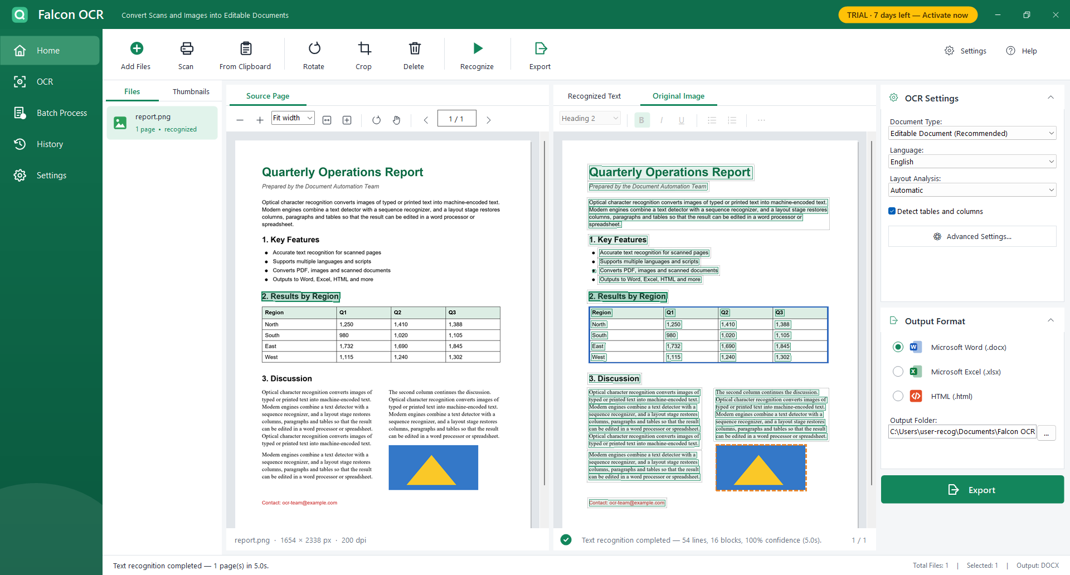
Figure 3 – Original Image tab: detected lines (green), table (blue), picture (orange, dashed), blocks (dotted)
Shows the source image with the analysis: every text line polygon in translucent green, table regions in blue, pictures dashed orange and paragraph blocks dotted grey. Clicking a line selects it everywhere. The formatting toolbar is disabled on this tab.

6. SCR-04 Quick OCR
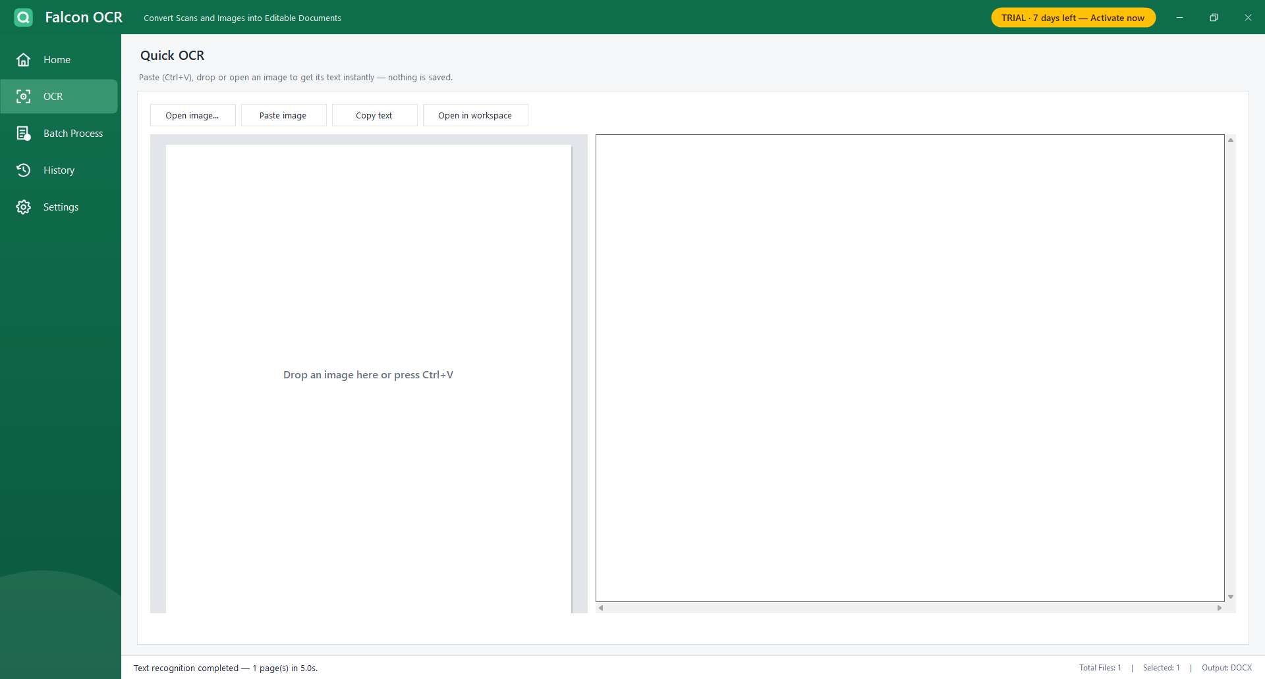
Figure 4 – Quick OCR page
Table 9 – SCR-04 controls
Control | Behavior
Open image… | Open an image or PDF (first page) and recognize it immediately.
Paste image / Ctrl+V | Recognize the clipboard image or the first copied file.
Drop zone (left) | Drop an image; shows the image with the detected lines.
Text (right) | Plain text in reading order; editable.
Copy text | Copies the text.
Open in workspace | Adds the source file to the Home workspace.
Info line | 'n lines · confidence · time · language' or the error.

7. SCR-05 Batch Process
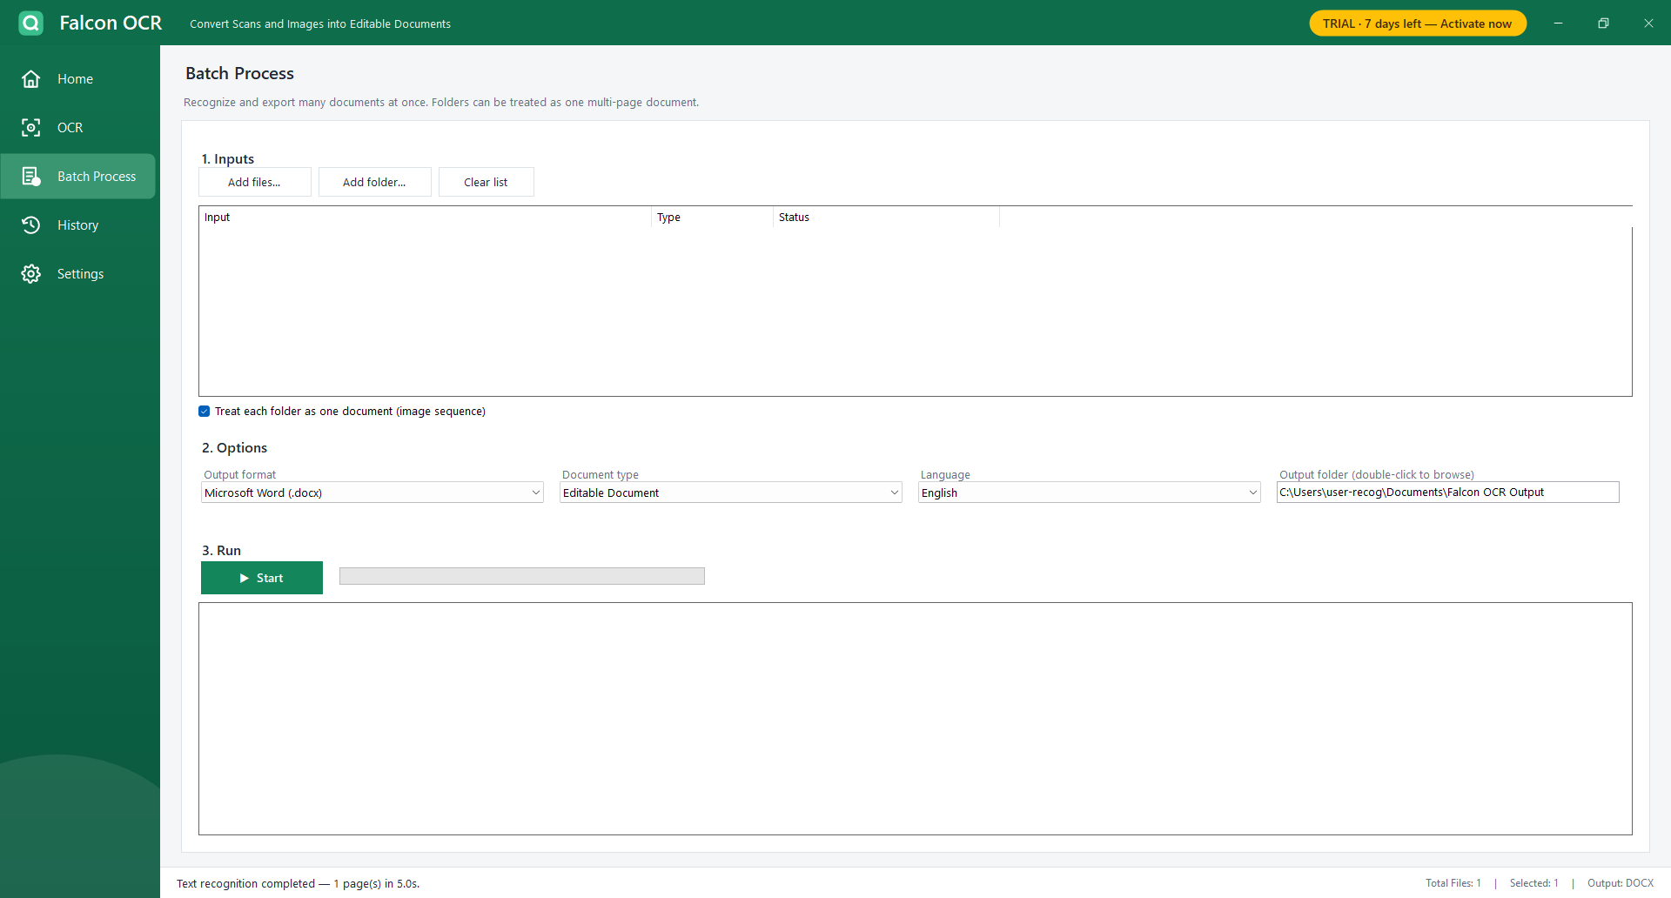
Figure 5 – Batch Process page
Table 10 – SCR-05 controls
Control | Behavior
Add files… / Add folder… / Clear list | Fill the input list (drag and drop also works). Folders become one image-sequence document when 'Treat each folder as one document' is checked; PDFs in folders are added individually.
Input list | Columns Input, Type, Status (Waiting, Recognizing…, Page i/n, Done, Failed, Stopped).
Output format / Document type / Language / Output folder | Options of the run (defaults from Settings; double-click the folder box to browse).
Start / Stop | Processes the items not yet 'Done'; progress bar and status bar percentage; confirmation to open the output folder at the end.
Log | Time-stamped result per document (✓ name (pages, seconds) → output file, ✗ error) and summary.

8. SCR-06 History
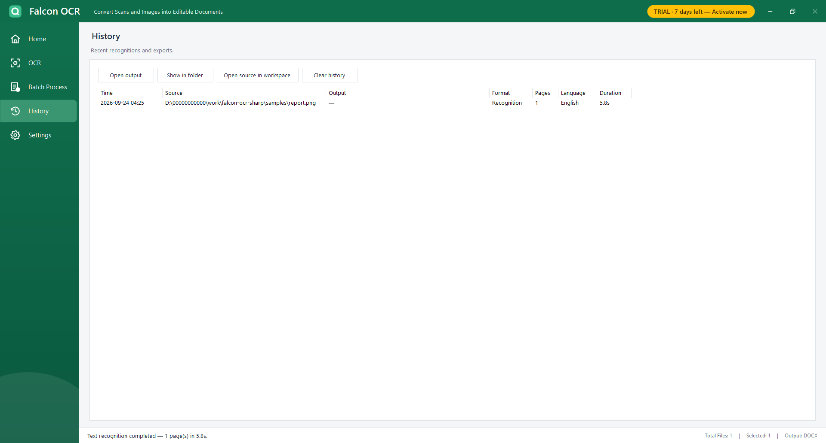
Figure 6 – History page
List (newest first) with Time, Source, Output, Format ('Recognition' or DOCX/XLSX/HTML/TEXT), Pages, Language and Duration. Buttons: Open output (also double-click), Show in folder, Open source in workspace, Clear history (confirmation).

9. SCR-07 Settings
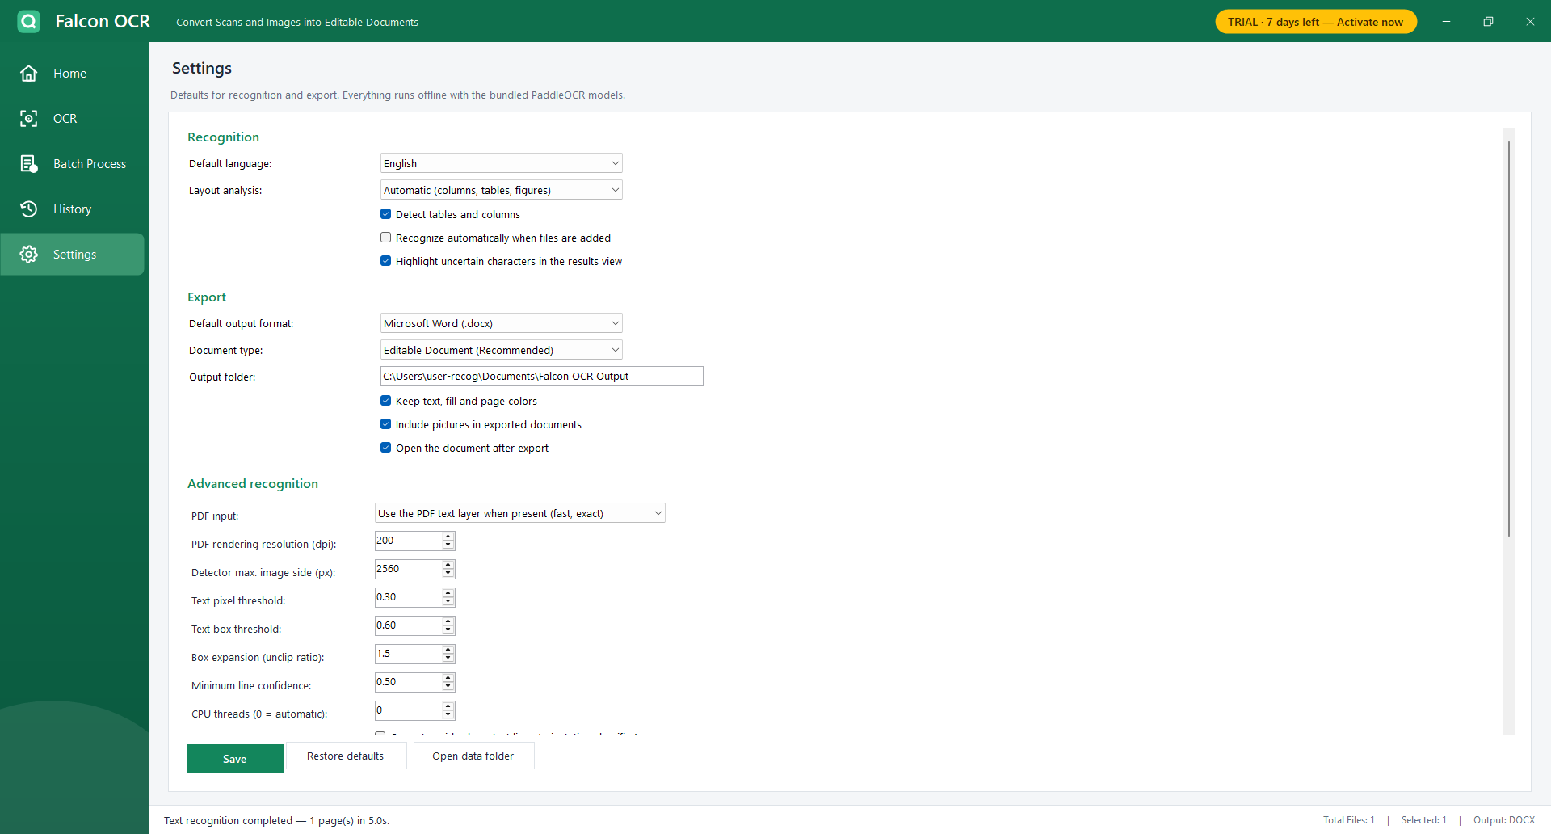
Figure 7 – Settings page
Table 11 – SCR-07 sections
Section | Fields
Recognition | Default language, Layout analysis, Detect tables and columns, Recognize automatically when files are added, Highlight uncertain characters.
Export | Default output format (incl. Plain text), Document type, Output folder (double-click to browse), Keep text/fill/page colors, Include pictures, Open the document after export.
Advanced recognition | Same fields as SCR-09.
OCR models (offline) | Model folder and each model with ✓ / ✗ missing and size; supported languages.
License | State (✓ licensed to …, ⏳ trial n of 7 days, ✗ invalid) and machine code; Change license key… (SCR-08), Copy machine code.
Buttons | Save (applies to the workspace immediately), Restore defaults, Open data folder.

10. SCR-08 Activation window
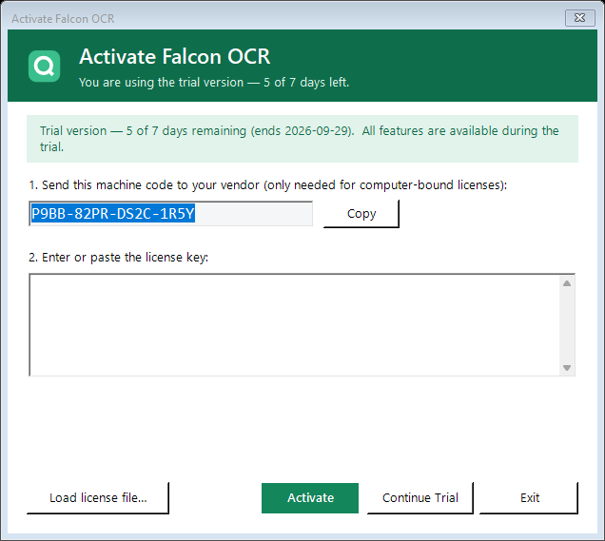
Figure 8 – Activation window while the trial is running
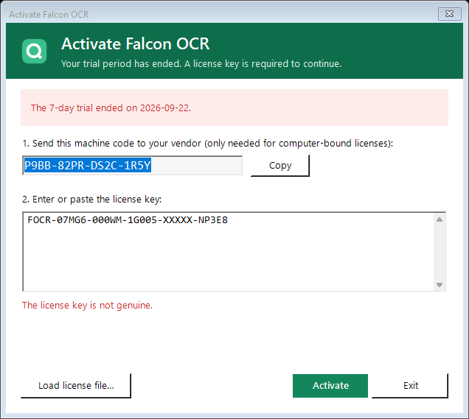
Figure 9 – Activation window after the trial has ended
Table 12 – SCR-08 elements
Element | Behavior
Header | 'Activate Falcon OCR' and a subtitle: trial days left / trial ended / enter your license key.
Banner | Green: 'Trial version — n of 7 days remaining (ends date). All features are available during the trial.' Red: 'The 7-day trial ended on date.' or tamper message.
Machine code + Copy | Read-only code (Consolas 13 pt) to send to the vendor for a computer-bound key.
License key box | Multi-line; accepts pasted keys with spaces/line breaks.
Status line (red) | Validation result: not genuine, malformed, other computer, expired, clock set back.
Load license file… | Reads the key from a .lic/.key/.txt file.
Activate (primary) | Validates and stores the key; success message; closes.
Continue Trial | Only at start-up while the trial is running; starts the application in trial mode.
Exit / Cancel | At start-up closes the application; from the running application closes the dialog.

11. SCR-09 Advanced OCR Settings
Table 13 – SCR-09 fields
Field | Range | Default | Effect
PDF input | Use the PDF text layer when present / Always run OCR | Text layer | FR-12
PDF rendering resolution | 100 – 600 dpi | 200 | Quality vs. speed for scanned PDFs
Detector max. image side | 960 – 6000 px | 2560 | Small text on large pages vs. speed
Text pixel threshold | 0.05 – 0.9 | 0.30 | Lower finds faint text
Text box threshold | 0.1 – 0.95 | 0.60 | Lower keeps uncertain boxes
Box expansion (unclip ratio) | 1.0 – 3.0 | 1.5 | Box padding around text
Minimum line confidence | 0 – 0.95 | 0.50 | Drops unreliable lines
CPU threads | 0 – 64 | 0 = automatic | 0 uses one thread per physical core
Correct upside-down text lines | check box | off | FR-13
Keep pictures and graphics as images | check box | on | FR-18
Buttons: Defaults (reload default values), OK (save), Cancel.

12. SCR-10 Other dialogs and messages
Table 14 – Messages
Situation | Message / dialog
Recognize on a recognized document | '"name" is already recognized. Recognize it again with the current settings?' OK / Cancel
Export with unrecognized pages | 'n of m pages are not recognized. Yes = recognize them first, No = export only the recognized pages' Yes / No / Cancel
Crop on a cropped page | 'This page is already cropped. Yes = crop further, No = restore the full page.'
Remove recognized document | 'Remove "name" and its recognition results?'
Close during recognition | 'Recognition is still running. Stop it and exit?'
Missing models | 'Some OCR model files are missing from the installation: … Run tools\fetch-dependencies.ps1 …'
Add files errors | 'Some files could not be opened:' followed by one line per file.
Rename… | Single-line input dialog with OK / Cancel.
Help | Workflow summary, keyboard shortcuts and license status.

13. SCR-11 License Key Generator (vendor)
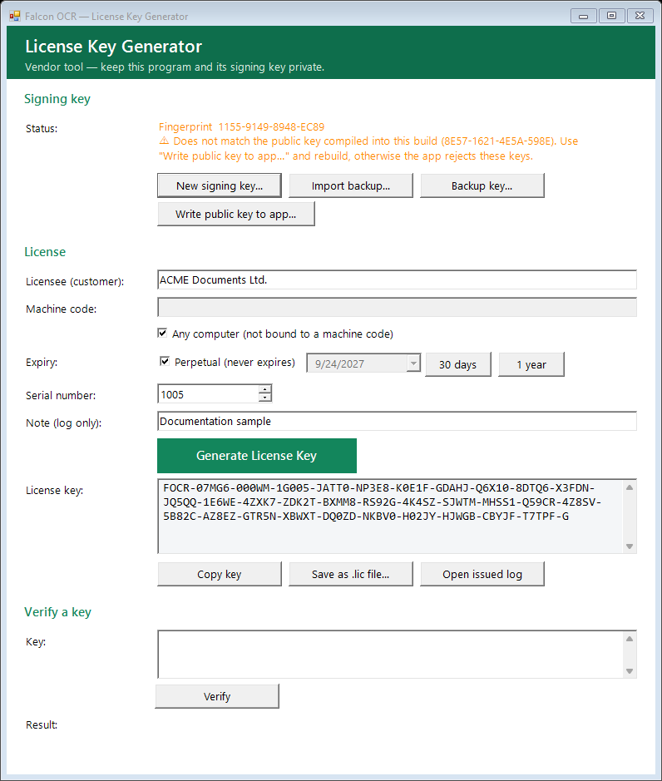
Figure 10 – License Key Generator
Table 15 – SCR-11 sections
Section | Controls
Signing key | Status: fingerprint and ✓ matches / ⚠ does not match the public key of the build. Buttons: New signing key…, Import backup…, Backup key…, Write public key to app…
License | Licensee, Machine code (upper case), Any computer, Expiry (Perpetual, date, 30 days, 1 year), Serial number (auto-increment), Note (log only), Generate License Key (primary), key box (read-only), Copy key, Save as .lic file…, Open issued log.
Verify a key | Key box, Verify, result (signature, licensee, serial, dates, machine).

14. Navigation map
Table 16 – Navigation
From | Action | To
Start-up (unlicensed) | Activate / Continue Trial / Exit | SCR-01 licensed / SCR-01 trial / closed
Any page | Navigation bar | SCR-02, 04, 05, 06, 07
SCR-01 title bar | Trial badge | SCR-08
SCR-02 | Toolbar Settings / Help | SCR-07 / help message
SCR-02 | Advanced Settings… | SCR-09
SCR-02 results | Original Image tab | SCR-03
SCR-04 | Open in workspace | SCR-02
SCR-06 | Open source in workspace | SCR-02
SCR-07 | Change license key… | SCR-08

